Notice of Instruction  5905 Breckenridge Parkway, Suite F  Tampa, Florida 33610  (813) 740-3888  Fax (813) 623-1342 | 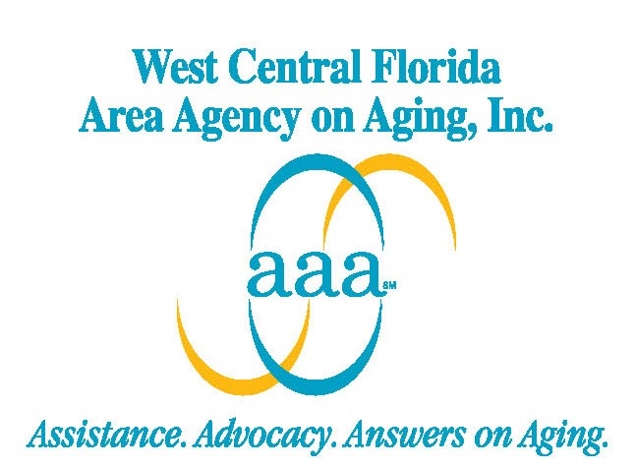

Notice of Instruction Number: 102710 – Case Narrative Training - kp

TO: All Lead Agencies

FROM: Katie Parkinson

DATE: October 27, 2010

SUBJECT: Client Case Record and Case Narrative Training

The purpose of this notice is to provide the attached, “Case Record and Case Narrative Training” PowerPoint Presentation and related technical assistance document. Case Management agencies should feel free to use these documents as tools when providing training to your staff.

WCFAAA would like to thank you and your staff for participating in the training webinar sessions provided on July 19, 2010. As previously discussed, the purpose of the training tool is to ensure that the DOEA, WCFAAA, and the case management agencies have ready access to useful information for technical assistance purposes. Your feedback is important to ensure that the tool is a living document that is well maintained with current and accurate information.

Should you have any questions about the information provided in this Notice of Instruction, please do not hesitate to contact your Program Manager.

Thank you for your assistance and cooperation.

Attachments

